**UPLOAD DOCUMENT TO GENERATE A QUIZ DEMO**

**Step 1: Click to Create a New Content to start creating your quiz**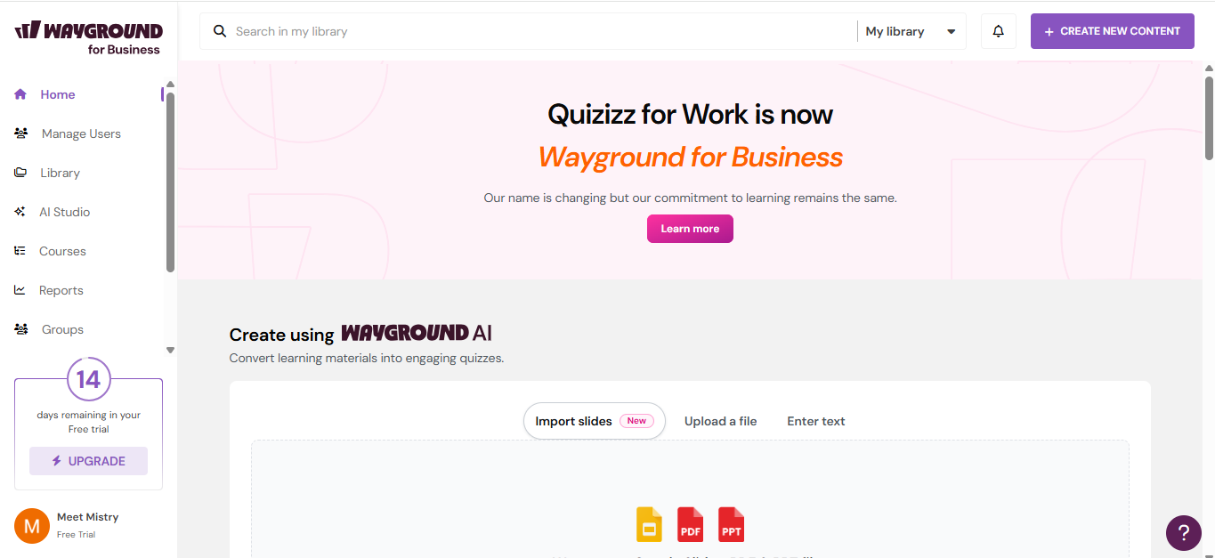

**Step 2: Select Create a Quiz using AI as it will help you to optimize your quiz in efficient manner**

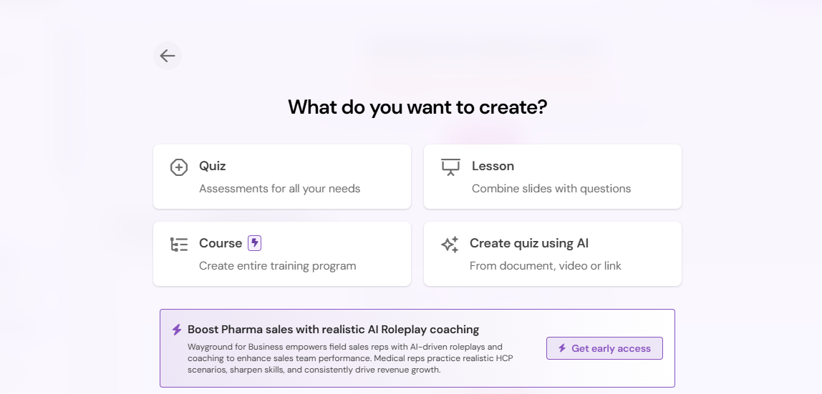

**Step 3: Select Extract document to generate a quiz where you upload your document and it will read, analyse and help you to generate the Quiz accordingly.**

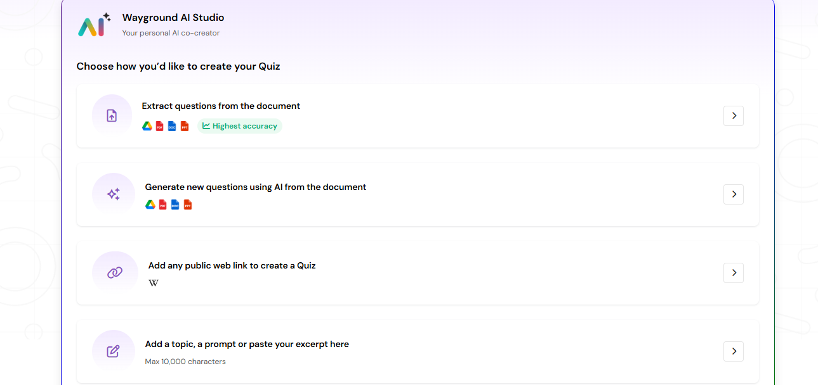

**Step 4: Upload your document here, then after click on to generate a quiz.**

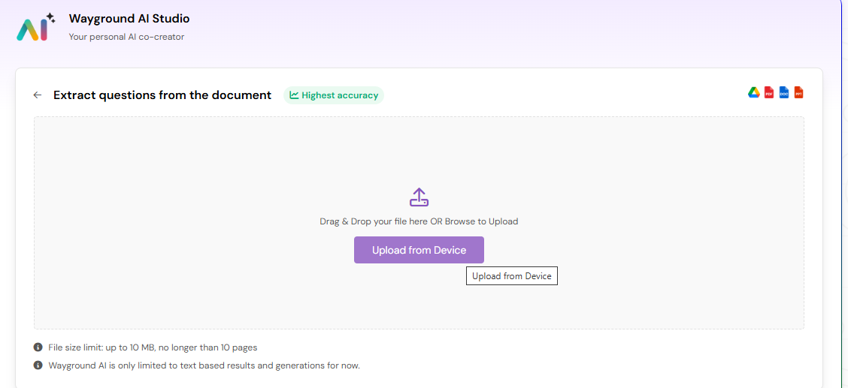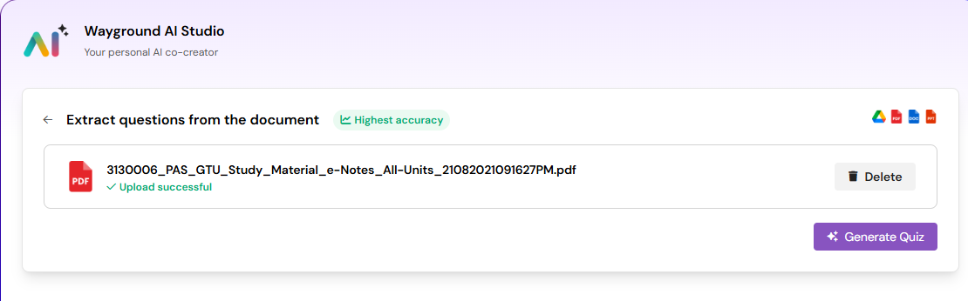

**Step 5: Quiz is now generating….**

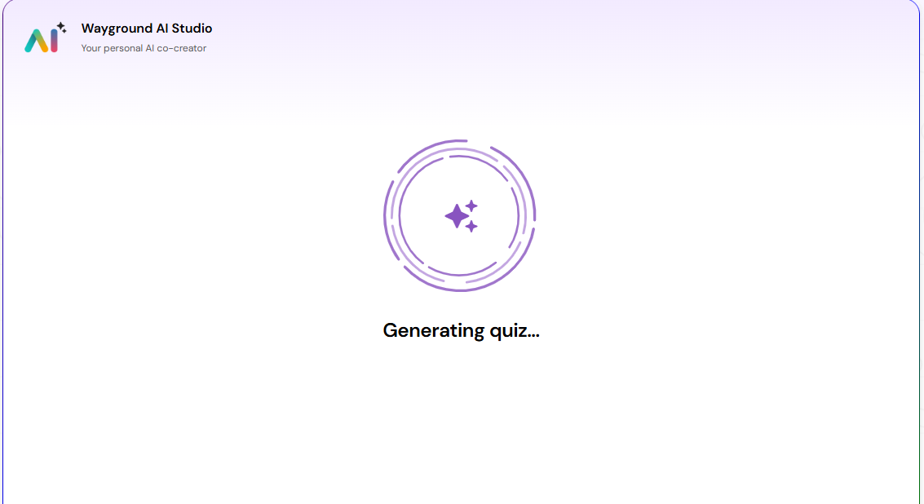

**Step 6: You can see the quiz has been created for you and also u can click to the settings tocheck many more editable options**

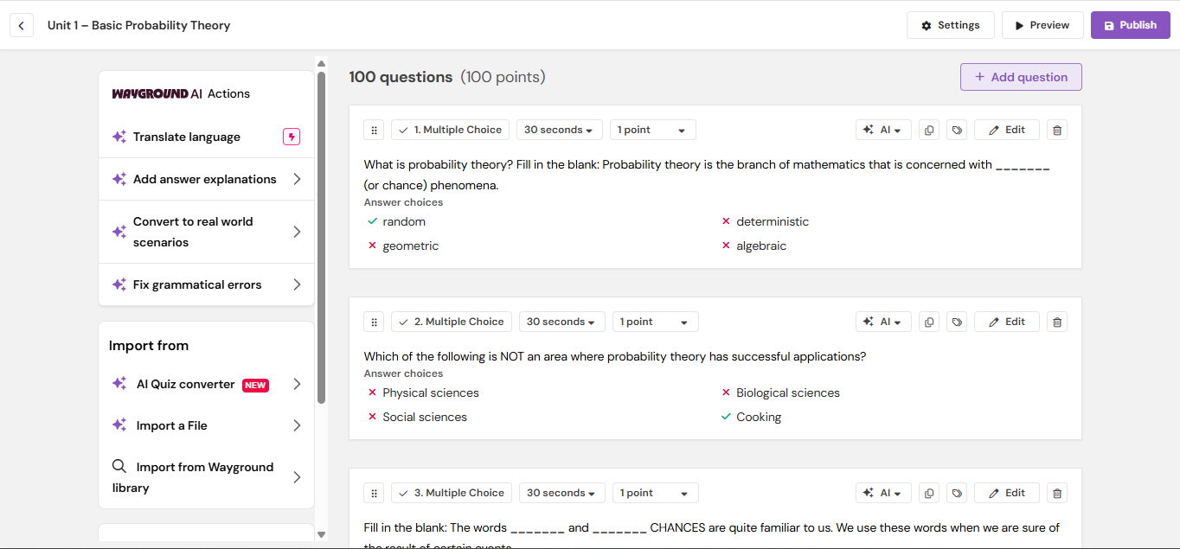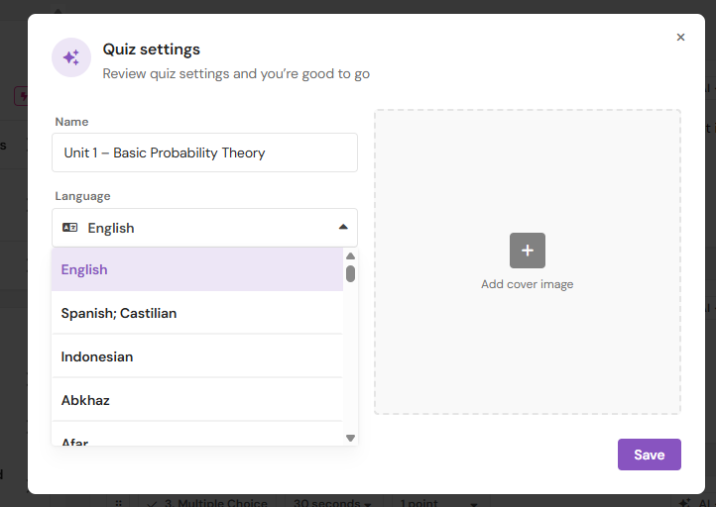

**Step 7: You can even add any extra question in between if required..**



**Step 8: Click to the Preview option to view your quiz how it will look like**

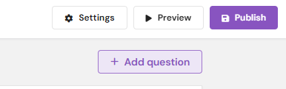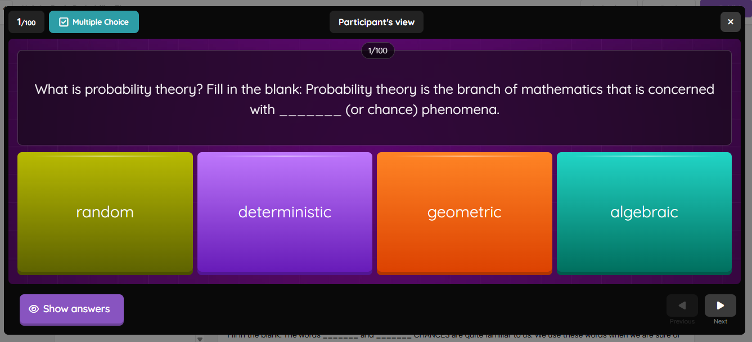

**Step 9: You can set an explanation portion for every question for understandability**

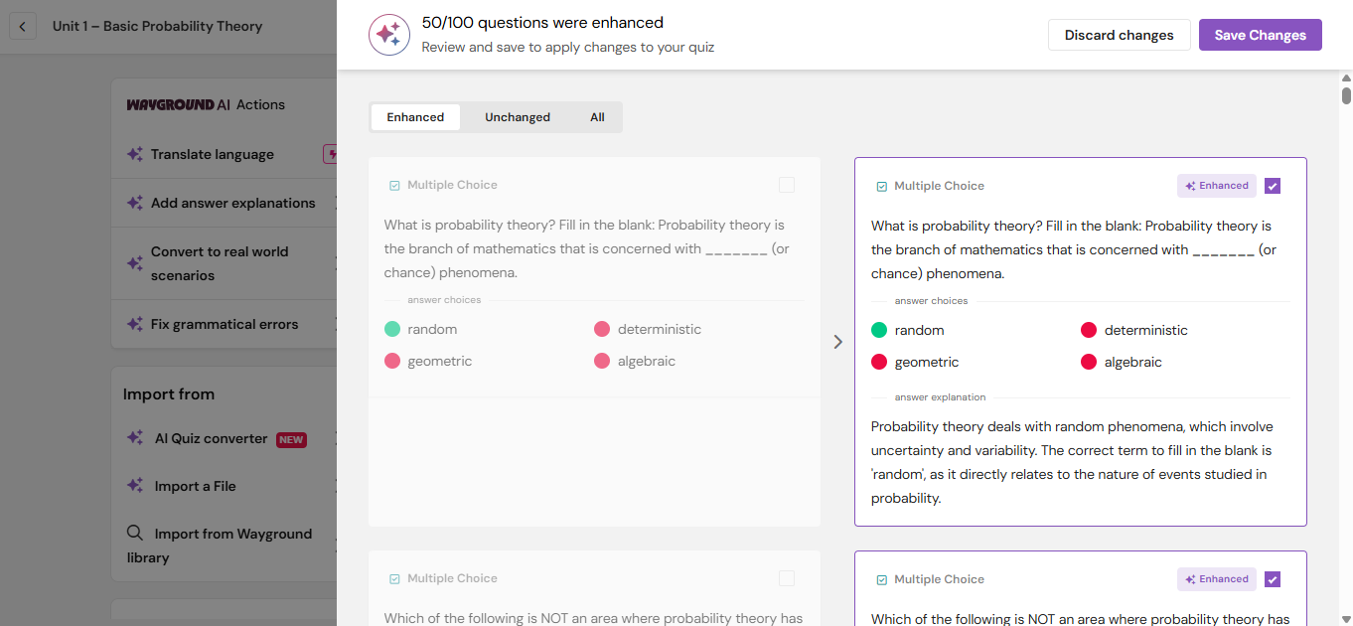

**Step 10: Now click on the publish to demonstrate your quiz in front of all the participants**



**Step 11: Now click on the start session which will further provide some details regarding the quiz like a scanner or a game code where participants can enter**

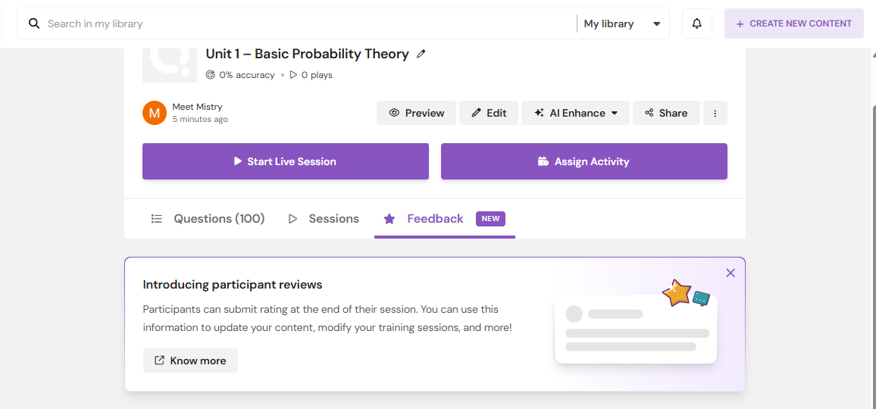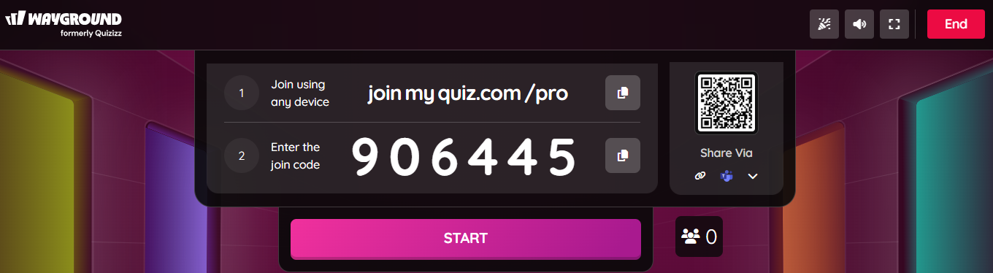

**Step 12: You can see 1 participant has entered the quiz room and we can even check on its leadership board and the accuracy of his correct answers.**

